**Prompt Engineering Documentation**

**. Introduction:**

* This documentation outlines the prompt engineering process used to interact with ChatGPT. Effective prompt engineering is essential for obtaining meaningful responses from AI models.

**. Overview of the Prompt Engineering Process:**

* The prompt engineering process involves selecting and refining prompts to guide AI model responses effectively.

Prompts used and Responses generated by ChatGPT using your prompts

***PROMPT*** -: you are a data scientist with the experience of 10 years and now you are given a task to use some data from introduction videos of candidates to generate results as should we hire the candidate?

analysis of communication and expertize in the subjects any other insight that might be useful now the data provided is of three kinds

1. emotion scores containing movie_id -Unique ID for a video image_seq- Image number angry- angry emotion score disgust- disgust emotion score fear- fear emotion score happy- happy emotion score sad- sad emotion score surprise- surprise emotion score neutral- neutral emotion score dominant_emotion- dominant emotion among other emotions gaze- Candidate is looking at the camera or not. 1 for looking and 0 for not looking blink- Eye blink (1 -> blink, 0 -> No blink) eye_offset- Deviation of eye from the camera elapsed_time- Timestamp in seconds(9 means at 9th sec)

2.transcript of video start: start time of the text end: end time of the text text: transcript spoken from start to end duration positive: positive score negative: negative score neutral: neutral score confident: confidence score hesitant: hesitance score concise: concise score enthusiastic: enthusiasm score speech_speed: Speed of the speech spoken we need to perform eda on it and create a report on it also containing graphs and visualizations with some code if needed . as we have done a lot of EDA on emotion score data now we will proceed towards transcript data . you being the data scientist will analyse will analyse and will get up to a conclusion which candidate to hire and which not. ok?

**Responses generated by ChatGPT-:** Certainly, I can help you perform an exploratory data analysis (EDA) on the transcript data and provide insights that will help in making a hiring decision. Let's break down the process into steps and create a report with relevant graphs and visualizations.

**Step 1: Data Loading and Initial Exploration**

**Step 2: Data Preprocessing**

**Step 3: Exploratory Data Analysis (EDA)**

***a) Sentiment Analysis***

***b) Confidence and Hesitance Analysis***

***c) Speech Speed Analysis***

**Step 4: Conclusion and Decision**

Based on the EDA of the transcript data, we can draw conclusions about the candidates' communication skills, confidence, hesitance, and speech speed. These insights can be combined with the emotion scores from the previous analysis to make an informed decision about whether to hire a candidate.

Some factors to consider when making the hiring decision:

- Candidates with a balanced sentiment score (positive, negative, neutral) may be preferred.

- High confidence and low hesitance scores indicate strong communication skills.

- Speech speed should align with the requirements of the job (e.g., not too fast or too slow).

You can set specific thresholds for these factors based on your hiring criteria and preferences.

Remember that this is just an initial analysis, and the final hiring decision should consider other factors like qualifications, experience, and cultural fit

***PROMPT*-:** the dataset of the TRANSCRIPT data contains start: start time of the text end: end time of the text text: transcript spoken from start to end duration positive: positive score negative: negative score neutral: neutral score confident: confidence score hesitant: hesitance scores concise: concise score enthusiastic: enthusiasm score speech_speed: Speed of the speech spoken. now give me some of the questions in which I should work to get up to conclusion which candidate to hire and which not-:

**Responses generated by ChatGPT** Certainly, when deciding which candidate to hire based on the transcript data, you can focus on various questions and criteria to evaluate their communication skills, confidence, and expertise. Here are some questions you can work on to make an informed decision:

1. **Overall Communication Skills:**

- Which candidates exhibit clear and concise communication?

- Do any candidates show signs of hesitance in their speech?

- Are candidates using positive language and expressions in their speech?

2. **Confidence and Enthusiasm:**

- How confident do candidates sound in their speech (based on the confidence score)?

- Who demonstrates enthusiasm and passion for the role or subject matter?

- Are there candidates who appear more confident and enthusiastic than others?

3. **Speech Speed and Clarity:**

- Is the speech speed of candidates suitable for effective communication?

- Are there candidates whose speech is too fast or too slow?

- Who maintains a balance between speech speed and clarity?

4. **Subject Matter Expertise:**

- Which candidates effectively convey their educational and professional background?

- Do any candidates highlight relevant experiences or qualifications?

- Who demonstrates a deeper understanding of the subject matter or industry?

5. **Positive vs. Negative Language:**

- Are candidates using positive language to describe their experiences and achievements?

- Do any candidates exhibit negativity or lack of confidence in their speech?

- How do candidates strike a balance between positive and neutral language?

6. **Conciseness and Clarity:**

- Who effectively conveys their points concisely and clearly?

- Are there candidates who provide detailed and relevant information without unnecessary elaboration?

- Who maintains a balance between being concise and providing necessary context?

7. **Alignment with Job Requirements:**

- How well do candidates align their skills and experiences with the job requirements?

- Do any candidates stand out as having a strong match for the role?

- Are there any candidates whose background and skills do not align with the job?

8. **Creativity and Adaptability:**

- Are candidates able to showcase creativity or adaptability in their speech?

- Do they discuss unique experiences or perspectives that could benefit the role?

- Who demonstrates versatility in their communication style?

9. **Engagement and Impact:**

- Which candidates are more engaging and likely to capture the audience's attention?

- Are there candidates whose speech has a significant impact, leaving a memorable impression?

- Who effectively communicates their value and potential contributions?

10. **Overall Fit for the Organization:**

- Consider the organization's culture and values. Which candidates seem like a good cultural fit?

- Are there any candidates whose communication style aligns with the organization's ethos?

- Who can potentially contribute positively to the team and workplace environment?

By evaluating candidates based on these questions and criteria, you can make a more informed decision about which candidate to hire. You may assign scores or rankings to each candidate for each criterion and then weigh these scores to reach a conclusion. Additionally, conducting interviews or further assessments can complement the analysis of the transcript data for a comprehensive hiring decision.

***PROMPT-:*** write a code in python for; ‘ Which candidates exhibit clear and concise communication? ‘

**Responses generated by ChatGPT** o determine which candidates exhibit clear and concise communication, we can define a metric that combines the "concise" score with factors like speech speed and confidence. We'll calculate a composite score for each candidate, and candidates with higher scores will be considered more clear and concise. Below is the Python code to perform this analysis: 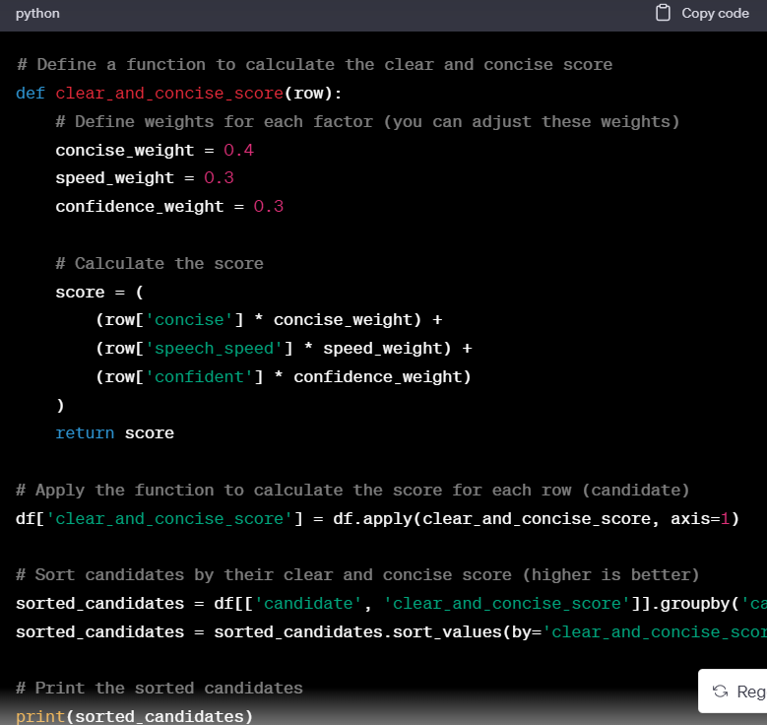

***PROMPT-:*** write a PYTHON code for;’ How confident do candidates sound in their speech (based on the confidence score)?’

**Responses generated by ChatGPT-:** To analyze how confident candidates sound in their speech based on the confidence score, you can calculate the average confidence score for each candidate. Here's a Python code snippet to achieve this:

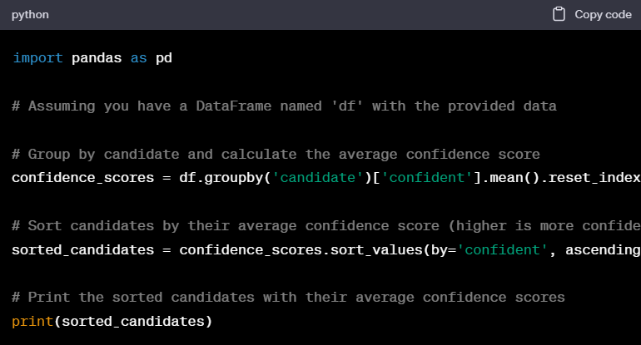

***PROMPT-:*** write a PYTHON code for ;’Are there candidates whose speech is too fast or too slow?’

**Responses generated by ChatGPT-:** To assess if the speech speed of candidates is suitable for effective communication, you can analyze their speech speed scores. The analysis could involve calculating summary statistics or visualizing the distribution of speech speeds. Here's a Python code snippet to help you get started with this analysis:

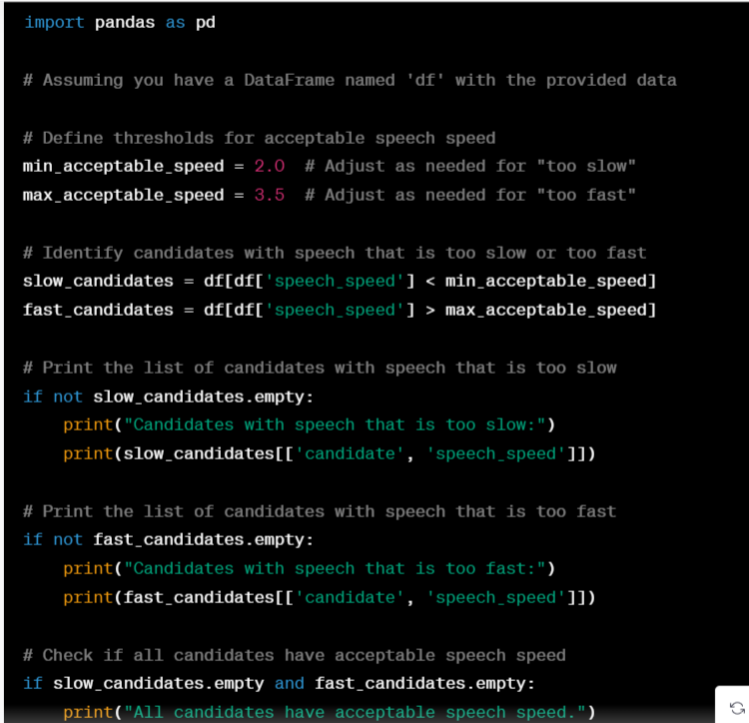

“SIMILARLY I ASKED CHATGPT TO WRITE CODES ON TRANSCRIPT SCORE ON PYTHON ON SOME OTHER QUESTIONS GIVEN BY CHATGPT IN THE PREVIOUS PROMPT FOR BETTER ANALYSIS ON TRANSCRIPT DATA”

***PROMPT-:*** you being a data scientist give me some questions in which I want to perform exploratory data analysis on transcript data such that I get the result in the form of graph , plot, or pie chart. provide me some of the questions so that I can work on exploratory data analysis.

**Responses generated by ChatGPT-:** Certainly! Exploratory Data Analysis (EDA) can provide valuable insights when visualized through graphs, plots, and charts. Here are some questions you can explore, along with suitable visualization methods for each:

1. **Speech Speed Analysis**:

- **Question**: What is the distribution of speech speeds among candidates?

- **Visualization**: Histogram or density plot of speech speeds.

2. **Confidence and Hesitance Analysis**:

- **Question**: How confident do candidates sound in their speech based on the confidence score?

- **Question**: Do any candidates show signs of hesitance in their speech based on the hesitance score?

- **Visualization**: Box plots or violin plots for confidence and hesitance scores.

3. **Conciseness and Enthusiasm Analysis**:

- **Question**: Which candidates exhibit clear and concise communication based on the concise score?

- **Question**: Who appears more enthusiastic in their speech based on the enthusiasm score?

- **Visualization**: Bar chart or radar chart comparing concise and enthusiasm scores.

4. **Background Conveyance**:

- **Question**: Do candidates effectively convey their educational and professional background based on the transcript data?

- **Visualization**: Pie chart showing the percentage of candidates who effectively convey their background.

5. **Alignment with Job Requirements**:

- **Question**: How well do candidates align their skills and experiences with the job requirements based on their speech?

- **Visualization**: Stacked bar chart showing the alignment of skills and experiences with job requirements.

6. **Balancing Positive and Neutral Language**: - **Question**: How do candidates strike a balance between using positive and neutral language in their speech?

- **Visualization**: Stacked bar chart comparing positive and neutral scores.

7. **Engagement and Audience Attention**:

- **Question**: Who are the candidates that appear more engaging and likely to capture the audience's attention based on the analysis of speech content?

- **Visualization**: Radar chart showing engagement and attention scores.

8. **Contributions to Workplace Environment**:

- **Question**: Who can potentially contribute positively to the team and workplace environment based on their speech?

- **Visualization**: Pie chart showing the percentage of candidates who can contribute positively.

9. **Speech Patterns and Patterns Over Time**:

- **Question**: Are there any noticeable patterns or trends in speech speed, confidence, hesitance, conciseness, or enthusiasm over the course of a candidate's speech?

- **Visualization**: Line plot or time series plot for speech attributes over time.

10. **Comparison and Ranking**:

- **Question**: Can you rank candidates based on their performance in different categories, such as confidence, conciseness, enthusiasm, etc.?

- **Visualization**: Bar chart or radar chart for ranking candidates in various categories.

These questions and visualizations will help you gain a deeper understanding of the candidate data and identify patterns, outliers, or areas of strength and improvement in their speech and communication skills. Depending on your specific analysis goals, you can choose the most relevant questions and visualizations for your EDA.

***PROMPT-:*** write a code on Comparison and Ranking: Question: Can you rank candidates based on their performance in different categories, such as confidence, conciseness, enthusiasm, etc.? Visualization: Bar chart or radar chart for ranking candidates in various categories.

**Responses generated by ChatGPT-:** To rank candidates based on their performance in different categories and create a bar chart for visualization, you can follow these steps in Python using Pandas and Matplotlib. I'll provide a code example for ranking candidates in terms of their confidence, conciseness, and enthusiasm scores:

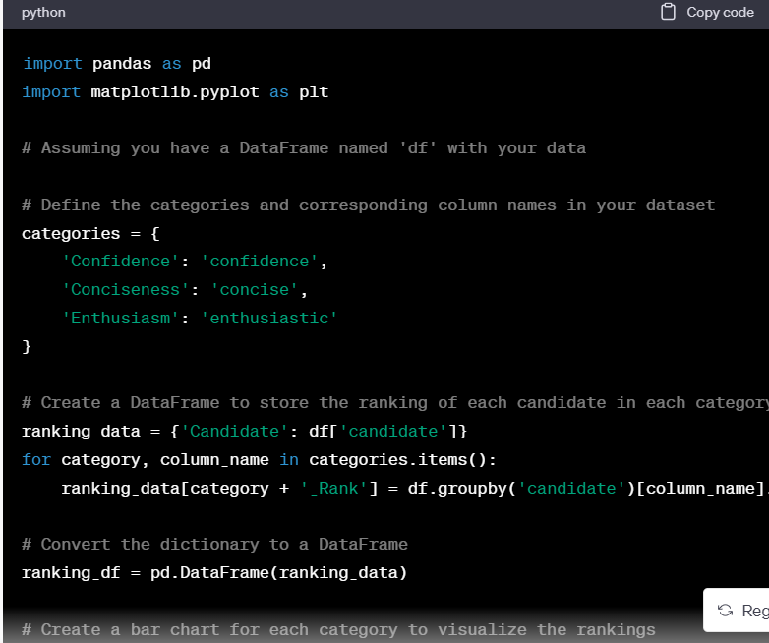

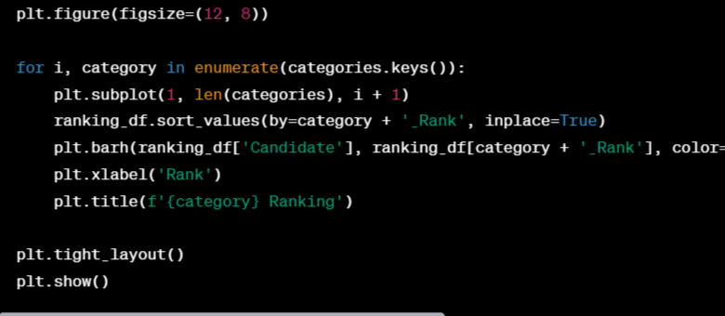

***PROMPT-:*** write a code on Speech Speed Analysis: Question: What is the distribution of speech speeds among candidates?

**Responses generated by ChatGPT-:** If you want to analyze the speech speed of each candidate individually, you can create a box plot to visualize the distribution of speech speeds for each candidate. Here's the code to do that:

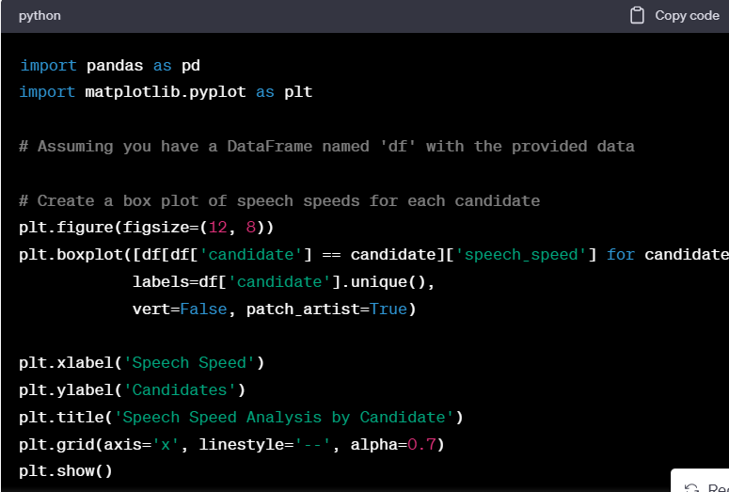

“SIMILARLY I ASKED CHATGPT TO WRITE CODES ON PYTHON ON SOME OTHER QUESTIONS on *transcript score RELATED* TO EXPLORATORY DATA ANALYSIS GIVEN BY CHATGPT IN THE PREVIOUS PROMPT FOR BETTER VISUALISATION ON TRANSCRIPT DATA”

***PROMPT-:*** now we will perform exploratory data analysis on EMOTION SCORE data. you are a data scientist with the experience of 10 years and now you are given a task to use some data from introduction videos of candidates to generate results as should we hire the candidate? emotion scores containing movie_id -Unique ID for a video, image_seq- Image number, angry- angry emotion score, disgust- disgust emotion score fear- fear emotion score, happy- happy emotion score sad- sad emotion score, surprise- surprise emotion score ,neutral- neutral emotion score ,dominant_emotion- dominant emotion among other emotions, gaze- Candidate is looking at the camera or not. 1 for looking and 0 for not looking, blink- Eye blink (1 -> blink, 0 -> No blink) eye_offset- Deviation of eye from the camera elapsed_time- Timestamp in seconds(9 means at 9th sec).

“I SHARED THE PORTION OF EMOTION SCORE DATA FOR BETTER UNDERSTAND OF DATA TO CHATGPT”

**Responses generated by ChatGPT**-: I understand that you have emotion score data for 10 candidates based on their video resumes, with each score associated with a specific image_id representing different instants in their videos. To analyze this data and make a decision on whether to hire a candidate or not, you can follow these steps:

1. **Data Exploration**:

- Start by examining the emotion score data for each candidate.

- Look at the distribution of scores, identifying any patterns or trends.

2. **Define Criteria**:

- Determine the criteria or thresholds you want to use for evaluating candidates based on their emotion scores. For example, you might consider certain emotions (e.g., confidence, enthusiasm) as positive indicators and others (e.g., nervousness, disinterest) as negative indicators.

3. **Aggregate Scores**:

- Calculate an overall emotion score for each candidate by aggregating their scores over all the images or instants in their video resumes. You can use different methods like averaging, summing, or weighted averages based on the importance of specific instants.

4. **Rank Candidates**:

- Rank the candidates based on their aggregated emotion scores. You can create a ranked list to see which candidates scored the highest.

5. **Consider Other Factors**:

- Emotion scores can provide valuable insights, but they should not be the sole basis for hiring decisions. Consider other factors like qualifications, experience, skills, and any other relevant information you have about the candidates.

6. **Set a Threshold**:

- Decide on a threshold or cutoff point for hiring. Candidates who meet or exceed this threshold may be considered for further evaluation, while those below it may not.

7. **Interview and Assessment**:

- If the emotion score data helps you shortlist candidates, conduct interviews or assessments to further evaluate their suitability for the position.

8. **Final Decision**:

- Combine the emotion score analysis with other evaluations and assessments to make a final decision on whether to hire a candidate or not.

Remember that while emotion scores can provide insights, they are just one piece of the puzzle. It's important to consider the whole picture when making hiring decisions to ensure that the candidates you select are the best fit for the role and your organization.

***PROMPT-:*** provide me some of the questions in which I should work on my emotion data to get to a conclution which candidate to hire

**Responses generated by ChatGPT**-: Certainly, with the additional information about the columns in your emotion score data, you can ask more specific questions to analyze the data effectively and make a decision on which candidate to hire. Here are some questions you can work on using this data:

1. **Which candidate exhibited the most positive dominant emotion (e.g., happy) throughout their video?**

- This can indicate a generally positive attitude, which might be desirable for many roles.

2. **Did candidates maintain eye contact by looking at the camera?**

- Eye contact can be a sign of engagement and confidence. Did candidates who maintained eye contact perform better?

3. **Did candidates who blinked more frequently perform differently from those who didn't blink as much?**

- Excessive blinking might indicate nervousness or discomfort. Did it affect their overall performance?

4. **Is there a correlation between the length of the video (elapsed_time) and the emotions expressed?**

- Do candidates express more emotions as their video progresses? Does the length of the video impact their performance?

5. **Which candidate had the most consistent emotional expression throughout the video?**

- Consistency in emotional expression can be important for roles requiring emotional stability.

6. **Were there instances where a candidate's dominant emotion did not match the content they were discussing?**

- Emotion content alignment can be crucial for assessing authenticity.

7. **Did candidates express fear or discomfort during specific parts of their video?**

- Identify if there are particular sections of the video where candidates seem uncomfortable.

8. **Were there candidates who exhibited a wide range of emotions, and did this positively or negatively impact their evaluation?**

- Consider whether a diverse emotional range is an asset or a liability for the role.

9. **Did the dominant emotion vary between candidates, and did this variation correlate with their qualifications and experience?**

- Evaluate if certain emotions are more desirable for the role you are hiring for.

10. **Is there any correlation between the gaze (looking at the camera) and the emotional score?**

- Determine if candidates who maintain eye contact tend to perform better in terms of emotional expression.

11. **Did the order of emotions change over time for candidates, and did this impact their overall evaluation?**

- Analyze if the sequence of emotions expressed had an effect on the impression they made.

12. **Do candidates who express more neutral emotions have different qualifications or experience compared to those who express strong emotions?**

- Assess if neutral emotional expressions correlate with specific characteristics.

When working with this data, you can use statistical analysis and visualization techniques to answer these questions and gain insights into which candidate might be the best fit for your organization and the specific job role. Additionally, consider combining emotion data with other assessment criteria for a more comprehensive evaluation.

***PROMPT-:*** provide me the python code of Which candidate exhibited the most positive dominant emotion (e.g., happy) throughout their video?

**Responses generated by ChatGPT**-: To determine which candidate exhibited the most positive dominant emotion throughout their video, we can use Python with the pandas library for data manipulation and analysis. Here's a step-by-step code to find the candidate with the most positive dominant emotion

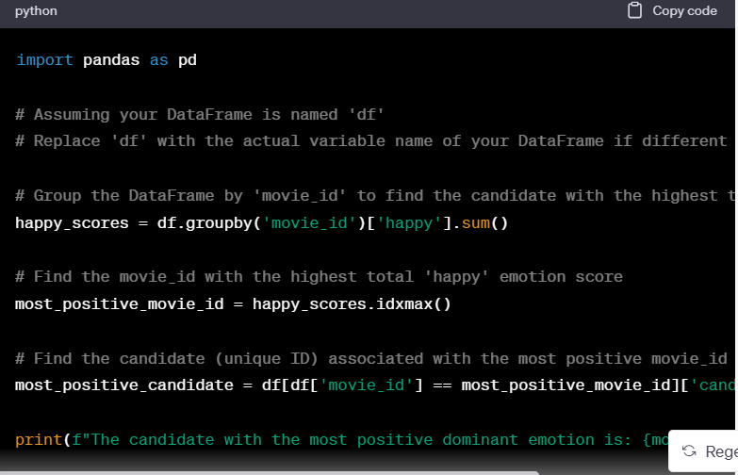

Make sure to replace **'df'** with the actual variable name of your DataFrame if it's different. Replace **'candidate_id'** with the actual name of the column containing candidate IDs in your DataFrame. This code should work once you provide the correct column name.

***PROMPT-:*** write a code on Are there candidates who consistently display nervousness or discomfort? Excessive nervousness may be a concern, particularly for client-facing roles

**Responses generated by ChatGPT-:** To identify candidates who consistently display nervousness or discomfort, you can analyze the 'fear' emotion score for each candidate across different image sequences in the dataset. You can calculate the standard deviation of the 'fear' emotion score for each candidate and look for candidates with low standard deviations, indicating consistency in displaying fear. Here's a Python code snippet to help you with this analysis:

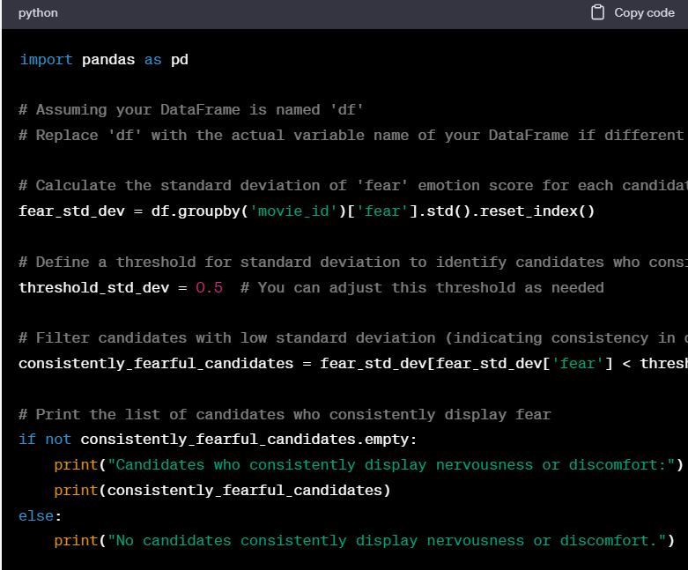

In this code, we first calculate the standard deviation of the 'fear' emotion score for each candidate using **groupby** and **std()**. We then define a threshold (**threshold_std_dev**) to determine what level of standard deviation qualifies as "consistently fearful." Candidates with a standard deviation below this threshold are considered to consistently display fear. You can adjust the threshold to be more or less strict, depending on your specific criteria. Finally, the code prints the list of candidates who meet this criterion.

“SIMILARLY I ASKED CHATGPT TO WRITE CODES ON EMOTION SCORE ON PYTHON ON SOME OTHER QUESTIONS GIVEN BY CHATGPT IN THE PREVIOUS PROMPT FOR BETTER ANALYSIS ON EMOTION DATA”

***PROMPT-:*** you being a data scientist give some of the questions I should work to get exploratory data analysis on my data , so that I get the result in the form of graph for better understanding .

**Responses generated by ChatGPT-:** Certainly! Exploratory Data Analysis (EDA) involves asking questions about your data and creating visualizations to gain insights. Here are some questions you can work on to perform EDA on your data:

1. **Distribution of Emotions:** What is the distribution of emotional scores (angry, disgust, fear, happy, sad, surprise, neutral) across all candidates? Create histograms or bar plots to visualize these distributions.

2. **Emotion Over Time:** How do emotional scores change over time (elapsed_time)? Plot line graphs to visualize the trend of emotions as videos progress.

3. **Dominant Emotions:** Which emotion is most dominant among candidates? Create a pie chart or bar plot to show the distribution of dominant emotions.

4. **Gaze vs. Emotion:** Is there a difference in emotional scores between candidates who look at the camera (gaze=1) and those who do not (gaze=0)? Use box plots or bar plots to compare emotional scores.

5. **Blink vs. Emotion:** Does eye blinking (blink) have any correlation with emotional scores? Visualize this relationship using scatter plots or bar plots.

6. **Emotion Range:** How diverse are the emotions expressed by candidates? Calculate the range (max-min) of emotional scores for each candidate and create a histogram or box plot to show the distribution of emotion ranges.

7. **Correlation Matrix:** Create a heatmap of the correlation matrix between emotional scores. This can help identify which emotions are strongly correlated or inversely correlated.

8. **Emotion vs. Dominant Emotion:** Are there candidates whose dominant emotion is different from the emotion they express the most? Visualize this using a bar plot or a stacked bar plot.

9. **Emotion by Image Sequence:** Does the emotion score vary significantly with image sequence? Create line plots or scatter plots to visualize this.

10. **Emotion by Movie ID:** Is there a variation in emotional expression across different videos (movie_id)? Use box plots or violin plots to compare emotions between videos.

11. **Emotion by Eye Offset:** Is there a relationship between eye offset and emotional scores? Visualize this using scatter plots or regression plots.

12. **Time vs. Gaze:** How does gaze (looking at the camera) change over time (elapsed_time)? Create a line plot or a stacked area chart to visualize this.

13. **Emotion Trends Over Movies:** Do certain movies exhibit specific emotional trends? Create line plots for emotional scores over elapsed_time, grouped by movie_id.

Remember to customize these questions based on your specific analysis goals and hypotheses. Visualizations such as histograms, bar plots, line plots, scatter plots, and heatmaps will be valuable in providing insights into your data during the exploratory phase.

***PROMPT-:*** write a python code for What is the distribution of emotional scores (angry, disgust, fear, happy, sad, surprise, neutral) across all candidates? Create histograms or bar plots to visualize these distributions.

**Responses generated by ChatGPT-:** To visualize the distribution of emotional scores across all candidates, you can create histograms for each emotional score (angry, disgust, fear, happy, sad, surprise, neutral). Here's a Python code snippet using the **matplotlib** library to do this:

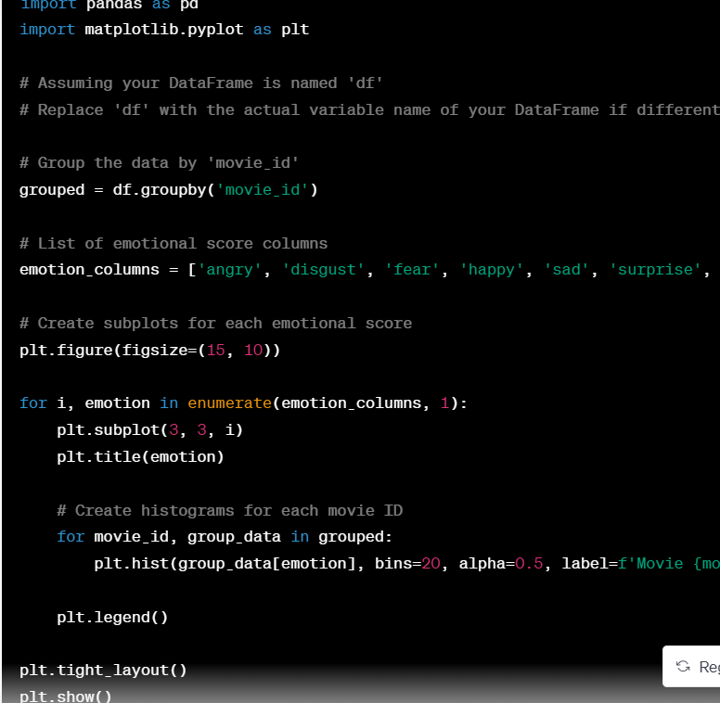

This code will generate separate histograms for each emotional score, showing the distribution of scores for each movie ID, making it easier to compare the emotional expressions across different movies. Make sure to import **matplotlib.pyplot** and load your DataFrame (**df**) with the dataset before running this code.

***PROMPT-:*** write a code on Emotion by Movie ID: Is there a variation in emotional expression across different videos (movie_id)? Use box plots or violin plots to compare emotions between videos.

**Responses generated by ChatGPT-:** To analyse the variation in emotional expression across different videos (movie_id), you can use box plots or violin plots. Here's Python code using Seaborn and Matplotlib to create box plots for each emotion score by movie_id:

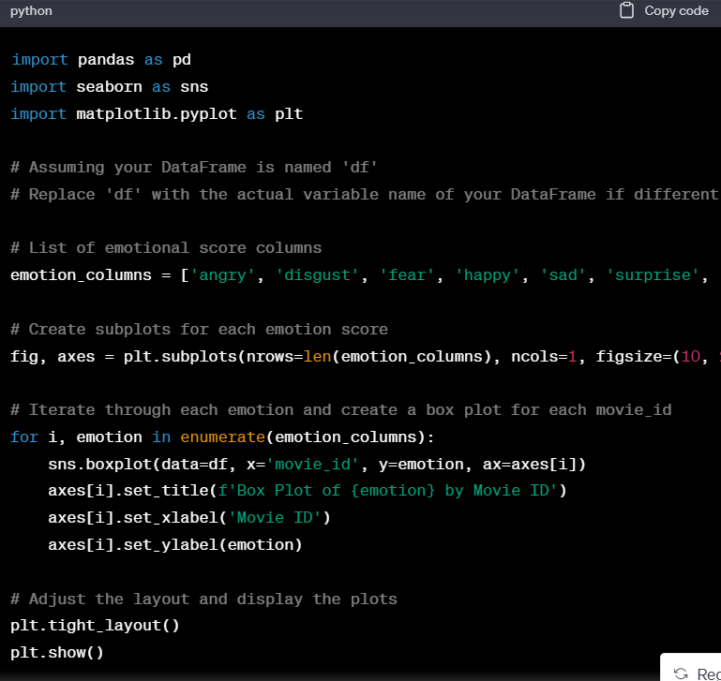

This code will generate a series of box plots, one for each emotion score (angry, disgust, fear, happy, sad, surprise, neutral), showing the distribution of each emotion by movie_id. Box plots are useful for visualizing the spread of data and identifying potential variations in emotional expression across different videos (movie_id). You can also use violin plots instead of box plots for a different visualization style.

“SIMILARLY I ASKED CHATGPT TO WRITE CODES ON PYTHON ON SOME OTHER QUESTIONS on *emotion score RELATED* TO EXPLORATORY DATA ANALYSIS GIVEN BY CHATGPT IN THE PREVIOUS PROMPT FOR BETTER VISUALISATION ON EMOTION DATA”

***PROMPT-:*** *i want to write the VBA code for PowerPoint presentation on the topic Visualizations (e.g., plots, charts) to support my insights on Exploratory Data Analysis Report containing 15 slides . here in the last 13 slides there should be an heading with the image containing the graph of the required heading.*

*the 13 headings are*

*_correlation heatmap of emotion scores*

*_Emotion Trends Over Movies*

*_patterns or trends in speech speed, confidence, hesitance, conciseness, or enthusiasm*

*_plot of emotion vs eye offset*

*analysis for confidence scores and hesitance scores*

*analysis of different emotions on different movie id*

*balancing positive and negative language*

*conciseness and enthusiasm analysis by candidate*

*distribution of dominant score*

*speech_speed_analysis_by_candidates*

*speech_speed_distribution*

*plot the emotion score when gaze is 1 or 0*

*remember in all these slides an image is there. ask me any questions if you have any doubt before proceeding*

**Responses generated by ChatGPT-:** Creating a PowerPoint presentation with VBA in Excel requires a good understanding of the PowerPoint object model. Below is a VBA code sample that generates a PowerPoint presentation with 15 slides, each containing one of the specified headings and an image (chart) related to that heading. This code assumes you have the data and charts ready to be inserted into the slides.

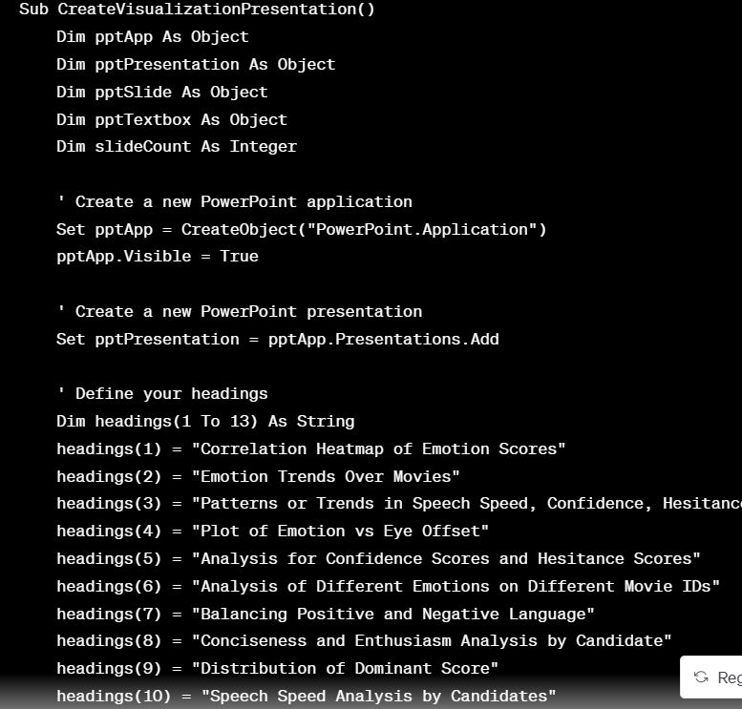

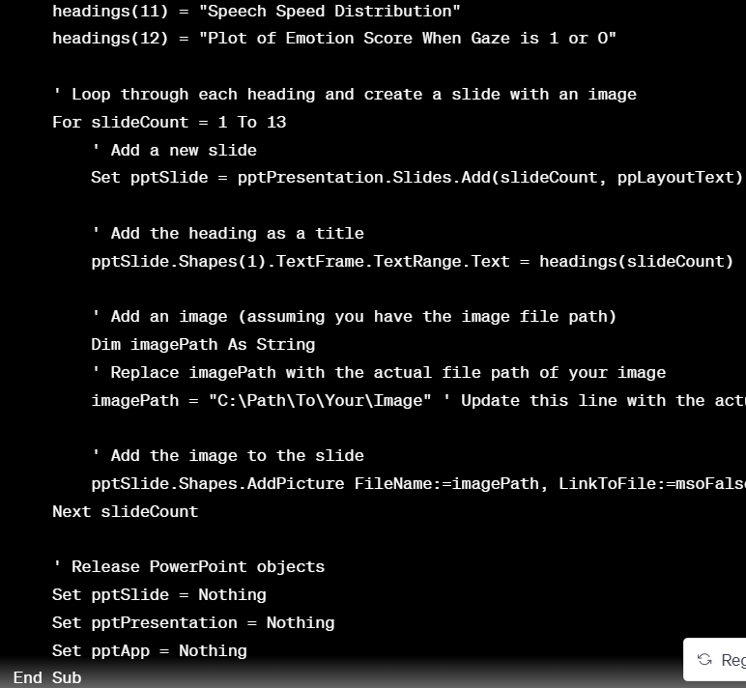

Before running this code, make sure you have:

1. Excel with the data and charts you want to insert into the PowerPoint slides.
2. Update the **imagePath** variable with the actual file path of your images.
3. Enable the PowerPoint Object Library reference in Excel VBA editor if not already enabled (**Tools > References > Microsoft PowerPoint XX.X Object Library**).

This code will create a new PowerPoint presentation with slides, each containing one of the specified headings and an associated image.